Week-3 Lab for Chapter 9

這課堂練習將建立虛擬的電視 (virtual TVs). 首先我們需要建立虛擬電視的樣板(blueprint, class). 所有虛擬電視將會有同樣的基本構件或特性. 下列是一般電視的基本構件或特性 :
- It has a brand name (品牌名稱).
- The TV screen has a specific size (特定尺寸).
- It has the following basic virtual controls (虛擬元件、功能) :
  - a control to turn the power (電源) on and off.
  - a control to change the channel (頻道).
  - a control for the volume (聲量).

基於上述原因，且每一個從TV class所建立的TV object 必須能將資訊儲存在其data fields中。因此一個TV object (class)必須有下列的data fields (attributes):
- MANUFACTURER : The MANUFACTURER (製造商名稱) attribute
- SCREEN_SIZE : The SCREEN_SIZE attribute will hold the size of the TV screen. This cannot change once the TV has been created so will be a named constant.
- powerOn : The powerOn attribute will hold the value true if the power is on, and false if the power is off.
- Channel : The channel attribute will hold the value of the channel station that the TV is showing.
- volume : The volume attribute will hold a number value representing the loudness (0 being no sound)

一個TV object必須能更動它的attributes的狀態(state, value). 因此TV class必須有下列的methods來更動TV object的attributes的狀態 :
- setChannel. The setChannel method will store the desired station in the channel field.
- power. The power method will toggle the power between on and off, changing the value stored in the powerOn data field from true to false or from false to true.
- increaseVolume. The increaseVolume method will increase the value stored in the volume field by 1.
- decreaseVolume. The decreaseVolume method will decrease the value stored in the volume field by 1.
- getChannel. The getChannel method will return the value stored in the channel field.
- getVolume. The getVolume method will return the value stored in the volume field.
- getManufacturer. The getManufacturer method will return the constant value stored in the MANUFACTURER field.
- getScreenSize. The getScreenSize method will return the constant value stored in the SCREEN_SIZE field.
We will also need a constructor method that will be used to create a TV object.

上述的TV class可用下列的 UML diagram來表示 :
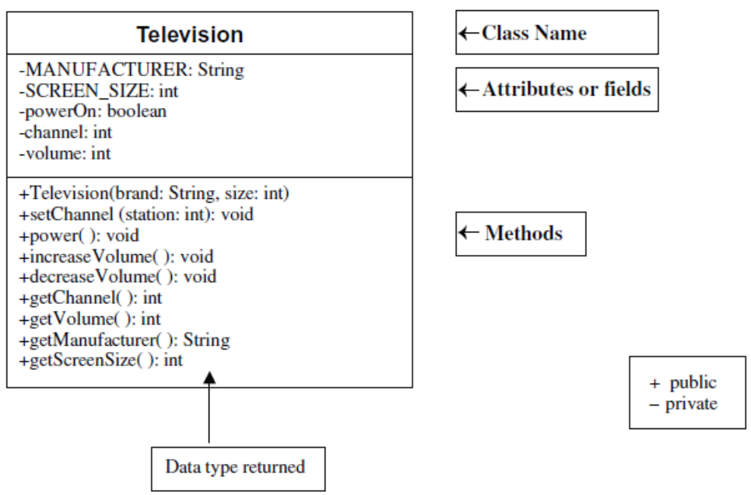
Task #1 : Creating a New Class
- Create a class called Television.
- Declare the 2 constant fields listed in the UML diagram.
- Declare the 3 data fields listed in the UML diagram.
- Save this file as Television.java.
- Compile and debug. Do not run.

Task #2 : Writing a Constructor
- Create a constructor that has two parameters, a manufacturer’s brand and a screen size.
- Inside the constructor, assign the values taken in from the parameters to the corresponding fields.
- Initialize the powerOn field to false (power is off), the volume to 20, and the channel to 2.
- Compile and debug. Do not run.

Task #3 : Methods
- Define accessor methods (得取值的方法) called getVolume, getChannel, getManufacturer, and getScreenSize that return the value of the corresponding field.
- Define a mutator method (更改值的方法) called setChannel accepts a value to be stored in the channel field.
- Define a mutator method called power that changes the state from true to false or from false to true. This can be accomplished by using the NOT operator (!). If the boolean variable powerOn is true, then !powerOn is false and vice versa (反之亦然). Use the assignment statement for this mutator method:
powerOn = !powerOn;
- Define two mutator methods to change the volume as follows.
- One method is called increaseVolume and will increase the volume by 1.
- The other method is called decreaseVolume and will decrease the volume by 1.
- Compile and debug. Do not run.

Task #4 : Running the application
- Use the driver program TelevisionDemo.java to test out your Television class. Copy the file TelevisionDemo.java from the class ftp site. Make sure it is in the same directory as Television.java.
- Compile and run TelevisionDemo and follow the prompts.

TelevisionDemo.java程式執行的輸出入如下 (粗體字是使用者的輸入) :
A 55 inch Toshiba has been turned on.
What channel do you want? 56
Channel: 56 Volume: 21
Too loud!! I am lowering the volume.
Channel: 56 Volume: 15

提示 :
- 請參考課本第351~352頁 Listing 9.3 TV.java (投影片第9頁)

